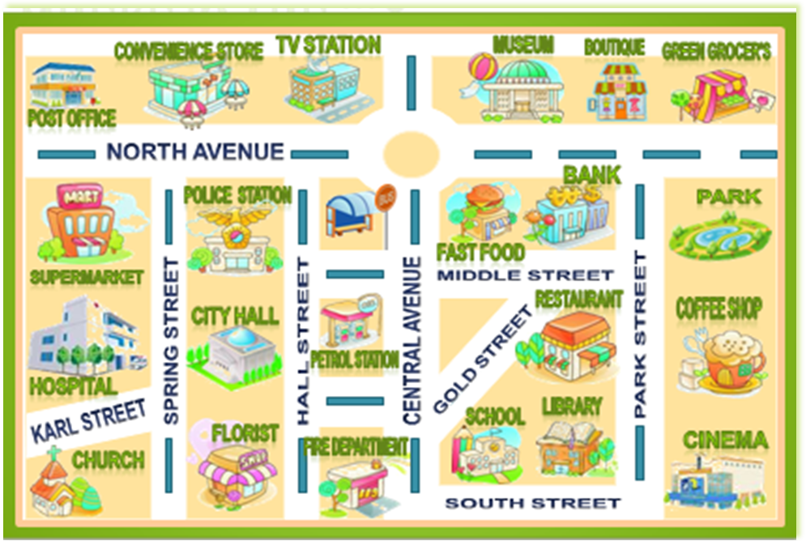

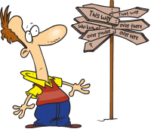
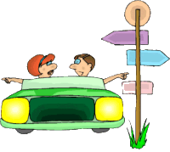
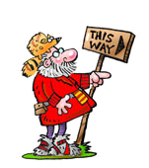
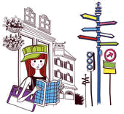

Asking for directions:
- Excuse me! Can you tell me the way to the…?
- Excuse me! How do I get to the …?
- Excuse me! Where’s the …?
- Excuse me! Is there a … near here?

Giving directions:
- Go straight ahead.
- Go along the street.
- Turn left.
- Turn right.
- Take the first/second turning on the left.
- Take the first/second turning on the right.
- Cross the street.
- Go past.
- Go through the park/ …
- Go across the bridge.
- Go as far as the roundabout…

Where is the…?
The school is …
  - on your right/left.
  - round the corner.
  - on the corner of … and …
  - next to the …
  - opposite the …
  - between the … and the …
  - in front of the …

Dialogue
- Excuse me! Can you tell me the way to the bank, please?
- Yes, of course. Go along Spring Street and take the first turning on the right. Go straight ahead, past the roundabout and then turn right into Park Street. Take the first turning on the right again and there is the bank.
- Thank you very much.

Look at the map and write these dialogues:
  - Bus Stop Restaurant
  - Cinema TV Station
  - Florist Green Grocer’s
  - School Police Station

