Birthday Vocabulary

Directions: Match the columns. Write the letters on the lines.

- cake
- gifts
- frosting
- guests
- birthday card
- knife
- birthday
- ribbon
- tape dispenser
- bow
- money
- “Surprise!”
- you
- wrapping paper
- matches
- young
- camera
- noisemakers
- party hat
- candles

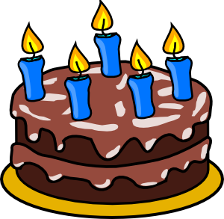
- “How old are _____?”
- blow these to make noise
- cash
- cut the cake with this
- holds tape
- invite them to the party
- light the candles with these
- made with flour, eggs, sugar
- opposite of old
- presents
- put these on the birthday cake
- spread this on top of cakes
- tape this on top of a gift
- the day you were born
- tie this around a gift
- use this to take photos
- wear this on your head
- wrap this paper around gifts
- write your signature inside
- yell this at surprise parties

